During the measurements the actuators were in air, but soaked to the solvent (PC + 0.1M LiTFSI) in every about 75 minutes, and then after about 10 minutes the measurement took place.
In long delays they were each one in a separate vial, stored horizontally, and in the same solvent.
Actuators of this type died too fast. Exactly similar happened with Ppy actuators made by Rauno Temmer. I even did not switch on the training cycles.
I expected them working at least 10000 cycles, but they were almost dead after 200.
Probably I did something wrong:
- Contaminated?
- Is the storing conditions important? They were sent us packed between two pieces of glass. I kept the samples each one in a separate vial, in solvent (except during damage in vacuum and under UV radiation)
- Wrong applied voltage?
- Weather? The equipment was in a room with air conditioner, at temperature 17º C.

An example:

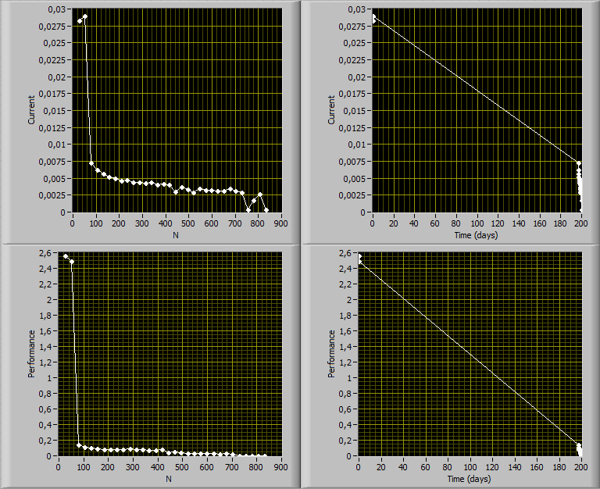

Legend of the samples
The samples got the following radiation/environment:

None | H26, A27, D27, C27, Q25, R26, B26
Gamma radiation 3600 Gy | A25, C25
Gamma radiation 1200 Gy | D25, F25
Gamma radiation 400 Gy | B25, E25
X-Ray radiation | G27, L27, F27, M25, E26, G26, P26,M26
Liquid Nitrogen (77K) 3 weeks | L25, K25, D26, I26, O27, A26, O26, J26
UV radiation | P25, J27, N27, Q27, L26, J25, K27, O25
Vacuum | I27, R25, M27, B27, H27, Q26, R27
Reserved | C23, S26, E27, F26

Directory structure:
All measurements of one sample are located in a separate folder named with the label of that sample:
A11, A12, B11, B12, etc...

The avi files are of no compression in order to process them. Packed with zip.

The data files are ordinary text files.
The files are named as TTTTTTTTTT_NNN_DD.txt and TTTTTTTTTT_NNN.avi.zip
where
TTTTTTTTTT is a 10-digit time stamp. This is a LabView parameter, and shows seconds since 12:00 a.m., Friday, January 1, 1904, Universal Time [01-01-1904 00:00:00].
For example 3413873960 corresponds to 6.03.2012, at 12:19:21 .
This parameter is good enough to generate unique filenames. Actually, this time is latched just after the last measurement point.

NNN is the label of a sample

DD is the type of data:
FU: Force measurement, (voltages, current, and force sensor output)
VU: Video measurement, (voltages and current)
VW: Video measurement,

Normally the files are in turns: a Force measurement file, and two Video measurement files of the same time stamp.

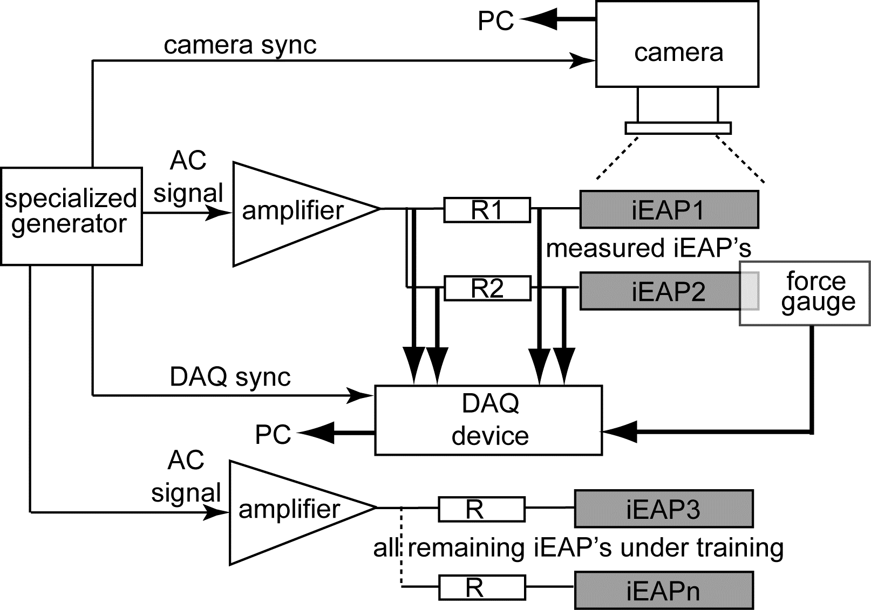
UF
UF0
UV
UV0
Schematics of the measurement equipment. The timing is realized by hardware sync with different sampling rates of camera and DAQ. Therefore each file contains a separate column Exact_time. This value enables aligning the results of the VU-file and VW-file.
Exact_time=0 corresponds to the start of the current measurement.

These samples suffered seriously from creep. As an example, here are frames from videos taken from one arbitrary sample: initial shape (amid), and max bending right and left. I removed the force sensor as pushing a a sample automatically to the sensor would certainly damage it.
(The number below a picture) shows the number of bends passed.
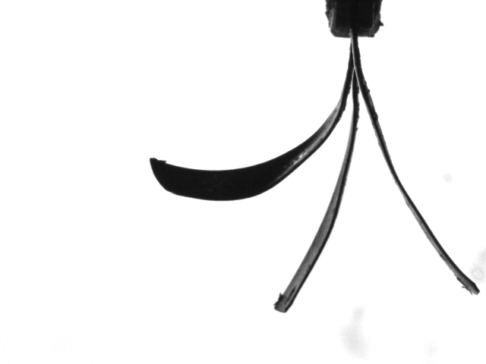 | 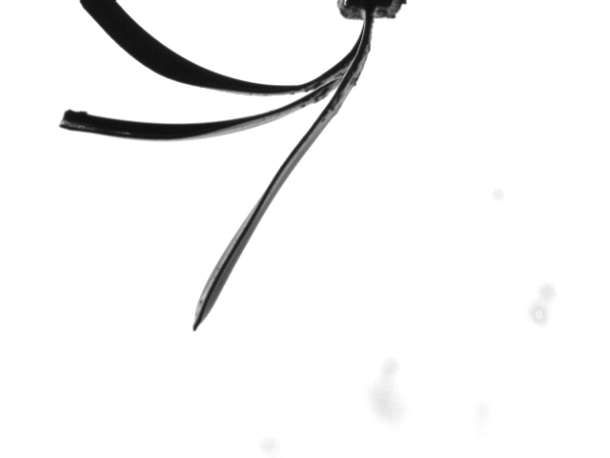 | 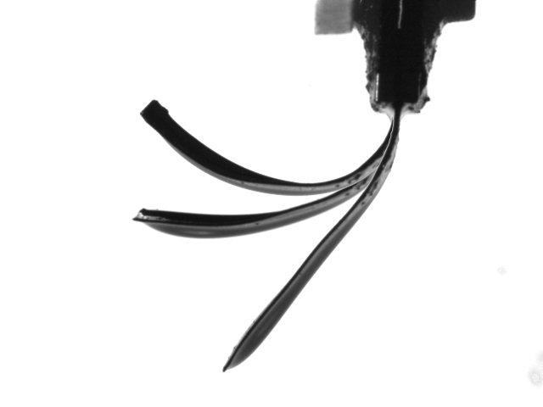
12 | 36 | 60
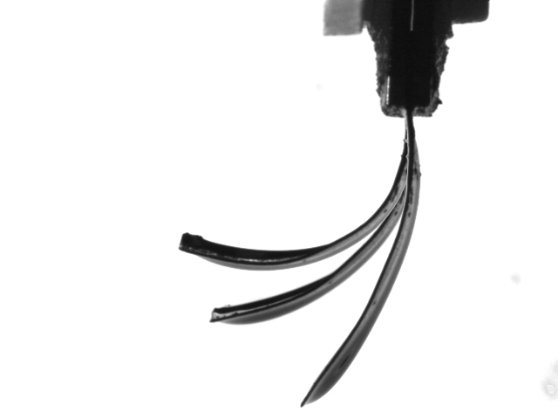 | 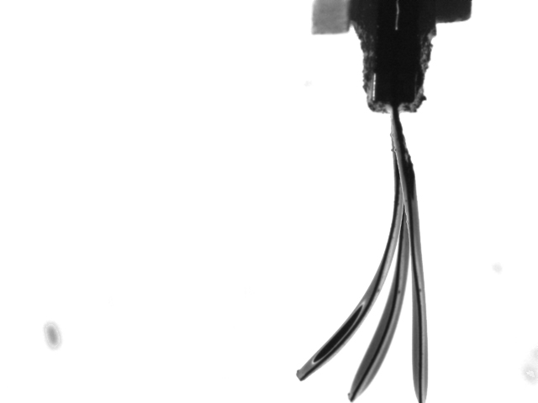 | 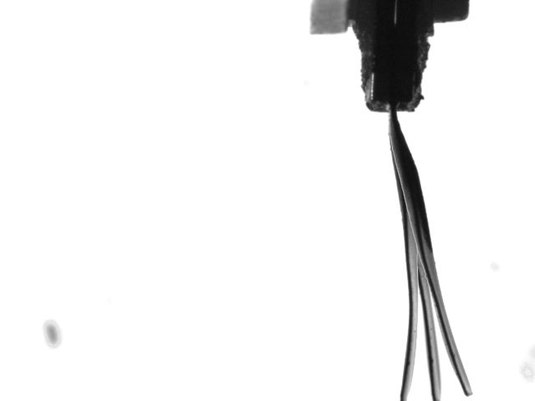
120 | 240 | 360
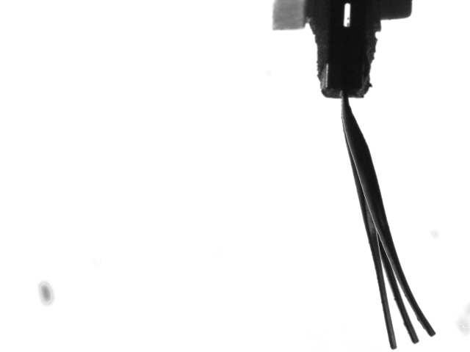 | 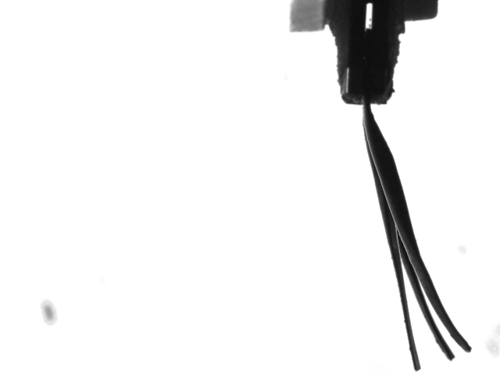 | 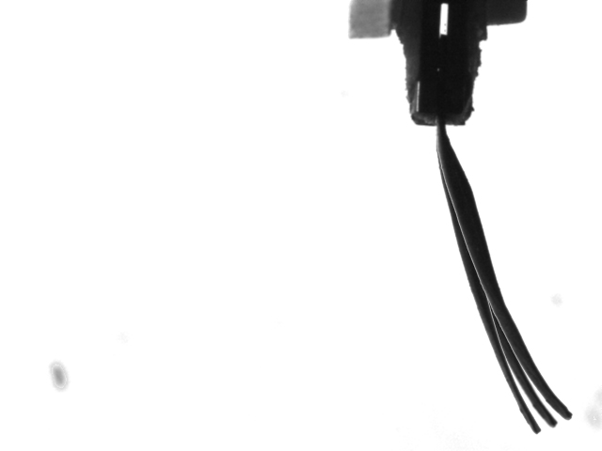
480 | 600 | 720
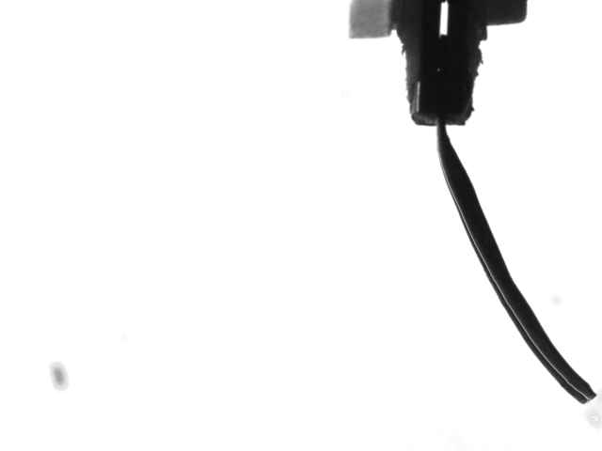
840

Format of the files:

VU-file:
Column1: Exact_time.
Column 2: Voltage at the input contacts of the sample, UV
Column 3: Voltage at the output of the amplifier UV0
Column 4: UV0-UV. NB! Electric current I is (UV0-UV)/10.10Ω

VW-file:
Column1: Exact_time.
Columns 2-8: relative angles of the vectors. The length of all vectors is 2.979 mm .

Summary files

I processed all data and produced a summary of each sample, located in the folder named Summary

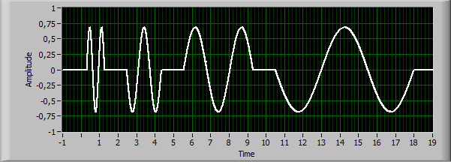

The signal consistas of 9 frequencies, each 3 half-periods. The actual frequencies were (in this order) 10, 5, 2.5, 1.25, 0.64, 0.32, 0.16, 0.08 and 0.04 Hz.
I tried to detect the positive and negative values and the correponding phases of the signals during the second and third half period.
The signals are Voltage, Current, and Absolute_angle for the video measurement.

The data files are ordinary text files.
The files are named as NNN.txt
where NNN is the label of the sample

Format of Summary files:

All columns are with 6 digits of precision, even when the actual value is Integer

Column 0: Reserved, sometimes I used this column for manual filtration of the rows
Column 1: total number of passed actuations
Column 2: Timestamp (see hereinabove)

The next columns are the found values for each frequency:

 | 10 Hz | 5Hz | 2.5Hz | 1.25Hz | 0.64Hz | 0.32Hz | 0.16Hz | 0.08Hz | 0.04Hz
Voltage amplitude | 3 | 12 | 21 | 30 | 39 | 48 | 57 | 66 | 75
Voltage zero level | 4 | 13 | 22 | 31 | 40 | 49 | 58 | 67 | 76
Voltage phase | 5 | 14 | 23 | 32 | 41 | 50 | 59 | 68 | 77
Current amplitude | 6 | 15 | 24 | 33 | 42 | 51 | 60 | 69 | 78
Current zero level | 7 | 16 | 25 | 34 | 43 | 52 | 61 | 70 | 79
Current phase | 8 | 17 | 26 | 35 | 44 | 53 | 62 | 71 | 80
Performance amplitude | 9 | 18 | 27 | 36 | 45 | 54 | 63 | 72 | 81
Performance zero level | 10 | 19 | 28 | 37 | 46 | 55 | 64 | 73 | 82
Performance phase | 11 | 20 | 29 | 38 | 47 | 56 | 65 | 74 | 83
For example, the performance – peak to peak at the lowest frequency corresponds to:
(Column111 – Column 109)

The values 1000.00000 ; -1000.000000; Inf; and –Inf mean: „could not detect anything reasonable“.
I tried several algorithms, but especially for the low signal it is impossible to detect the phase of the signal.

I included the LabView Reader.vi to read the Summary files. I tried to make this vi simple and apparent. Anyway, similar graphs can be produced by any package – Matlab, Excel, etc.

all questions to: punn@ut.ee

Andres Punning

