Reliability measurements of Ionic EAP Materials.
Unofficial report

Scope of the project

This project was conducted as a part of a contract with the European Space Agency (ESA), titled as „Radiation and temperature induced damage of ionic electroactive polymer materials for MEMS devices in space“. Its scope involved the failure approach to the study of the reliability of several different ionic EAP actuator materials, after being subjected to different harsh environments: X-ray, UV and Gamma radiations, as well as low atmospheric pressure and very low temperatures. The levels of the environments were chosen according to the parameters of the Low Earth Orbit (LEO).
Here it must be emphasized that we did not try to demonstrate the huge number of actuations the actuators are capable to perform, or keeping the samples alive as long as possible.

Routine of the tests
Testing the lifetime of IEAP actuators was carried out by measuring their electrical and electromechanical impedances under continuous load, until their performance decreased under a defined level. The survival tests were carried out with 7 different types of iEAP actuators. The total number of samples was 50-70 pieces of each. The samples were divided into separate portions for the different environmental afflictions, 7-10 pieces of each. The measurements of reliability were carried out using identical methodology upon the different iEAP types, and included the following steps:
- The initial performance of each particular sample was recorded;
- In 60 days the performance of each particular sample was recorded again. This step allows determining the rate of the spontaneous self-degradation of the materials.
- All separate sets of samples were subjected to their pre-assigned harsh environments;
- In 60 days from the Step 2 the lifetime of the samples under continuous loading was determined.
- In about 10 days after the Step 4 the final performance of the samples was recorded again.
Between the steps the samples were kept in ideal conditions – each one in a separate vial, possibly containing the appropriate solvent.

Materials tested

The iEAP materials included the following:
- An Emi-Tf containing Nafion membrane. The electrodes consisting of TiC-derived carbon and solution of Nafion were applied by airbrush. Finally, the membranes were sandwiched between two thin gold foils and fused together by hot-pressing at 160° C under 4 MPa
Fabricated in the University of Tartu, for the details see the material named Carbon(1) in http://dx.doi.org/10.1088/0964-1726/18/9/095028
- An EMIBF4 containing PVdF(HFP) membrane. The electrodes consisting of TiC-derived carbon and EMIBF4 are applied by hot-pressing.
Fabricated in the University of Tartu, for the details see

The summary of the iEAP materials is given in the following table:
No | By | Membrane | Electrodes | Electrolyte
A | UT | Nafion | CDC+gold | Emi-TF
B | UT | PVDF(HFP) | CDC | EMIBF4
C | Asaka | PVDF(HFP) | CNT | IL
D | Kim | Nafion | Pd+Pt | Water+Na⁺
E | Vidal | PVDF(HFP) | Ppy | EMITFSI
F | Alici | PVDF(HFP) | Au+Ppy | PC+LiTFSI (0.1M)
G | Rauno | PVDF(HFP) | Ppy | PC+LiTFSI (1.0M)

Testing procedure
Testing the lifetime of an IEAP actuators stands in the measurement of the frequency-dependence of the spectrum of bending amplitude and blocking force of each of them. As the lifetime of the actuators is expected in 10⁵ ... 10⁷ bending periods, it is not necessary to measure just each cycle. It is enough to test each sample after a while of working. Therefore after a sample is measured, it is removed from the measuring equipment and excited separately to perform a reasonable number (200-2000) bending cycles.

Testing a single actuator
The procedure of testing a single actuator consists of the following steps:
- The actuator is attached to the electric contacts. The samples are somewhat fragile, therefore should be handled carefully. While attaching the actuator to the contacts, the operator must ensure that every sample is always oriented similarly and that the length of the sample between the contacts must be always similar.
- The camera, recording the bending response of the actuator, is focused to the sample. The actuator is excited with the frequency-dependent sine signal (sweep). The image processing is performed at once, therefore instead of the capacious video only the numerical results are saved. Simultaneously, the voltage and input current of the actuator are measured and saved.
- If desired, the camera is replaced by a force sensor. The blocking force is measured only in the straight position. The actuator is again excited with the similar frequency-dependent sine signal (sweep). Simultaneously, the voltage and input current of the actuator are measured and saved.
- The actuator is detached from the bench of measurements and attached to the separate testbench, where all actuators are excited with similar sine voltage of constant frequency.

Driving signal
Measuring the „wet“ EAP-s in dry environment should be performed as fast as possible. However, in case of „dry“ EAP-s it is not the case. For example the IPMC with water as electrolyte can be in air up to a few minutes only before it dries out and its parameters change drastically. Therefore, at least in case of the „wet“ EAP-s the round of measurement should not exceed a few minutes, covering all required frequencies.
The response might be highly nonlinear, therefore the wide spectrum signals, e.g. sweep, white noise, chirp, etc. are unobjectionable. Instead, the exciting signal was a gradual sweep. It consists of series sequence of sine signals of different frequencies. Each frequency lasts 3 half periods. The delay between the sequences is at least 0.5 half periods of the previous frequency while the initial phases are opposite.
An excerpt of the driving voltage signal is presented in Figure XX. The actual frequencies were (in this order) 10, 5, 2.5, 1.25, 0.64, 0.32, 0.16, 0.08 and 0.04 Hz. The whole signal lasted about 2.5 minutes, while the actual delays between the separate frequencies were different for the „floors“ of the equipment.

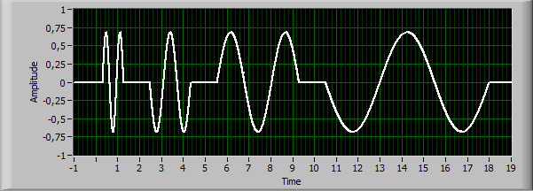
Figure XX. Excerpt of the driving voltage signal.

The process of measurement consists of two types of cycles: training cycles and measurement cycles. During the training cycle the actuator is actuating due to the sine input signal of appropriate frequency while its electrical and mechanical responses are not recorded. During the measurement cycle the actuator is engaged with the sweep signal while the mechanical and electrical parameters are recorded.
Measurements are carried out in cantilever configuration - one end of an actuator is fixed while the rest is free to move or to apply force . The samples are attached to their clamps during the whole measurement process. This way we avoid their damage and ensure that they are not turned over between the cycles.
During the measurement cycle the sample is held horizontally and edgewise, in this configuration the mass of the actuator itself distorts less its free bending.
During the training cycle the sample is held hanging vertically. This is done for two purposes. Some samples exhibit creep - permanent deformation under the influence of the inner stresses. When it is hanging freely, the weight of the sample itself diminishes this effect. Another reason for the vertical placement of the samples is the need for soaking the wet types of IEAP actuators in their solvent. Some types of IEAP materials must be continously in the wet environment, others have to be moistened in a water or some solvent after every certain time.
Measurements are carried out in cantilever configuration - one end of an actuator is fixed while the rest is free to move. During measurement the sample is held horizontally and edgewise, in this configuration the mass of the laminate interferes less the measurements. During the training between the measurements

Operating voltage
The cycle of testing the lifetime of a large number of IEAP actuators stands in the measurement of the frequency-dependence of the spectrum of bending amplitude and blocking force of each of them. As the lifetime of the actuators is expected in 10⁵ ... 10⁷ bending periods, it is not necessary to measure just each cycle. It is enough to test each sample after a while of working. Therefore after a sample is measured, it is removed from the measuring equipment and excited separately to perform about 100-300 bending cycles.
The lifetime of the CIL-EAP materials with low driving voltage and reasonable low load or is reported being up to several hundred thousand or millions working cycles. Initially we intended to perform the long duration tests with moderate driving voltage values. Only later we realized that when the experiment lasts too long, it is rather impossible to separate the degradation caused by the environmental conditions and the pure temporal degradation. As the initial object of this project was comparing the degradation rates of irradiated and non-irradiated samples, we decided to accelerate the degradation by applying the driving voltage close to the maximum allowed. The voltage limit is determined by the electrochemical window of the particular material. In these conditions the experiment lasted only up to some weeks, while the total number of bending cycles reached 1000 – 50000, depending on the type of the material.

Performance of an actuator
In order to estimate the lifetime of the actuators, we had to choose the parameters, describing their performance. As the total number of samples is huge, an important requirement to the parameters is the possibility to perform the measurements automatically, regardless of the behavior of each sample.
Here we bring the possible parameters with the pros and cons.

Electrical parameters describing the performance of an actuator

Consumed electric current.
The overall character of the CIL-EAP actuators is capacitive. Therefore their consumed electric current is dependent on the working frequency. On one hand it is possible to characterize the devices by the frequency-dependence of the parameter: performance vs. consumed current. On the other hand observing the consumed electric current gives a convenient criterion to detect at least two modes of failure of the device.
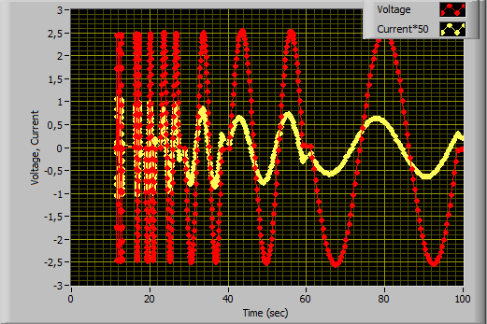
Time=0...100s

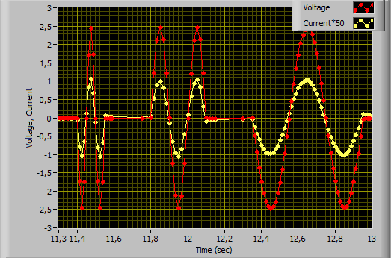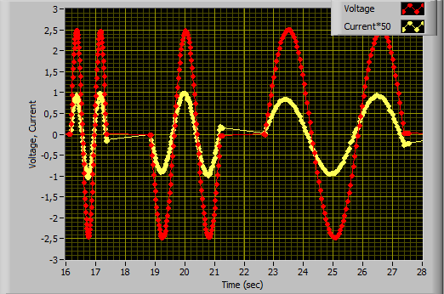
Time=11...13s Time=16...28s

Mechanical parameters describing the performance of an actuator

Blocking force
It may seem that measuring the blocking force is the easiest way to estimate the performance of an actuator, as the output is a single continous electrical signal. Nevertheless, adjusting the force sensor to an actuator is a delicate task. Especially, when the sample suffers from creep, it is impossible to push it to the force gauge with zero initial force, or without breaking the sample. This type of measurement was initially planned to the equipment, but the results are inconsistent and erratic.

Strain
In many scientific papers, the strain of bending actuators is calculated by the following formula:
$$ε=\frac{2Dw}{L^{2}+D^{2}}$$
where ε is strain, $D$ is deflection, and $L$ is the distance of the beam, where deflection is measured. The relation between strain and deflection is highly nonlinear and can be used in the case of small deflections only.

Displacement, tip displacement
Some publications use the displacement of the actuator at some defined distance from the input contacts of the actuator, e.g. at its free tip. as the parameter describing the performance of the actuator. It can be done easily for example using e.g. a laser displacement sensor. Similarly to the force gauge, the output is a single electrical signal. Nevertheless, this parameter describes the behavior of the actuator sufficiently adequately in the case of small displacements only as similar displacement can be achieved by various shapes of the actuator. Figure XX A and B demonstrate that the displacement of the two totally differently behaving actuators may be equal, while in the case C the measurement with a laser displacement sensor fails totally.

Figure XX. 3 cases of tip displacement

Vectorial interpretation of the shape of the actuator
The vectorial interpretation of the shape of the actuator expresses its bending with respect to the distance from the input contacts along the sample. The curved line representing the shape of the actuator is divided into vectors of equal lengths as depicted in figure 5, assuming that within every vector the curvature is constant. The shape of the actuator is characterized by a number of angles. Each next angle along the length of the actuator is relative to the previous one, while the angles of the first column may be arbitrary.
The image of the actuator is recorded by a camera and may be processed by some convenient image processing software or even manually with the ruler and protractor. A proper lighting and exposure greatly simplifies the procedure of placing the vectors. When the direction of the camera is set transverse to the actuator and the stage is illuminated from the background, the image of the actuator consists of a single contrast curved line.
Figure XX. Vector representation of an actuator.

The image of the bending sheet is divided into segments assumed to have a constant curvature. The principle of determining the angles is shown in Figure XX.
Consider an array of vectors $\vec{A_{i}}=\left(x,y\right), i=0..n$ with origin at the clamped end of IEAP, where $n$ is the maximum count of vectors in array. To obtain the vector representation of IEAP, the following algorithm can be used:
- Capture an image of an actuator;
- Consider a point $P_{0}$ located at the clamped end of the actuator;
- Construct an arc with origin $P_{i}$, radius $\left\|P_{i+1}-P_{i}\right\|$ and angle $φ$;
- Determine pixel intensities under the arc;
- Filter the intensities and locate global minimum;
- Rotate $P_{i+1}$ by an angle corresponding to the minimum;
- The search direction for next iteration is determined by $P_{i+2}=2P_{i+1}-P_{i}$;
- Increase $i$ and repeat from step 3 until reached to the end of the actuator;
To improve the result, the steps 3-5 are executed with multiple slightly modified radii, and the found minimums are averaged.

The length and total number of the vectors is a trade-off between the accuracy of the result and the resolution of the camera. It is self-evident that more vectors represent a complicated shape better. However, the relative error of detecting the angle depends on the discretization of the recorded image. Hence, it is important to provide sufficient resolution of the pixelated actuator to minimize image processing errors.
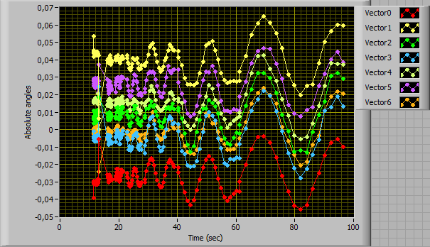
Time=0...100s

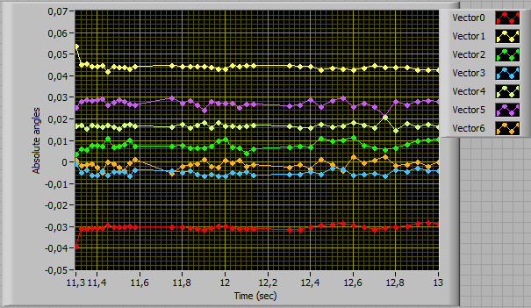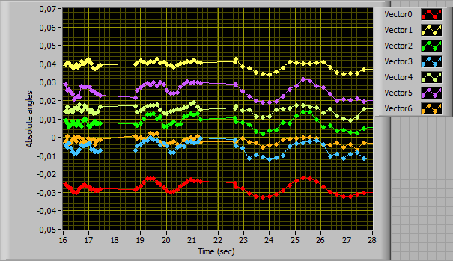
Time=11...13s Time=16...28s

Naturally, the angles of the segments are calculated from each frame of the video. With the properly illuminated sample, the detection of the 6 vectors from 175 frames took about 1 second only. This time was even less than saving the video file. The resulting 10-20 kilobytes data file enables exact reconstruction of the behavior of the actuator, while keeping the 50 Mbytes videos was obsolete.

Tip angle
The vectorial interpretation of the shape of the actuator allows determining the tangent of the tip. This is a reasonable parameter describing the shape of the whole actuator cumulatively. The angle between the tangents of the tip in the case of the maximal bending to the two opposite directions is a convenient parameter describing the performance of the actuator. The absolute angle of the last vector reflects the tip angle with imperceptible error
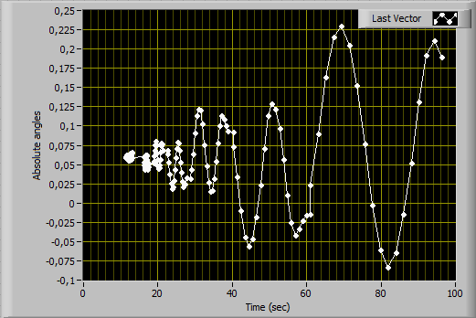
Time=0...100s

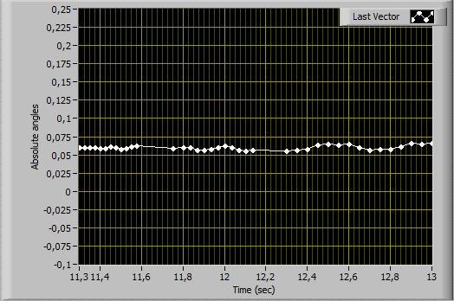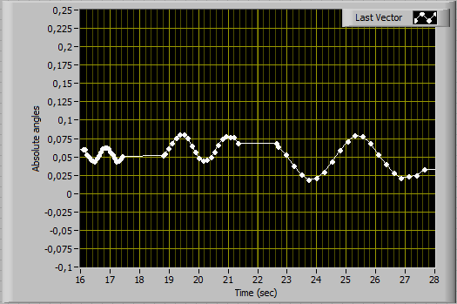
Time=11...13s Time=16...28s

Maximal angle
A convenient numerical quantity to estimate the performance of the actuator is the angle between the maximal bending displacements to the opposite directions (Figure XX-A). This parameter is valid until the actuator bends out of the camera’s field of view, and reflects adequately the performance even in the case of considerable initial creep of the sample.
A B
Figure XX. Performance of an actuator
In the case of creep the angles to the two directions may be unequal (Figure 5-B), nevertheless the angle of the whole sweep describes the performance sufficiently adequately.
β

Electrical parameters describing the performance of an actuator

Consumed electric current.
The overall character of the CIL-EAP actuators is capacitive. Therefore their consumed electric current is dependent on the working frequency. On one hand it is possible to characterize the devices by the frequency-dependence of the parameter: performance vs. consumed current. On the other hand observing the consumed electric current gives a convenient criterion to detect at least two modes of failure of the device.

Electrical impedance
Knowing the performance of the actuator as well as the corresponding amplitudes of voltage and electric current as depicted in Figure XX, we can describe the behavior of the actuator with three frequency-dependent impedances.

Figure XX. Amplitudes of voltage and electric current.

Electrical impedance is the measure of the opposition that an actuator presents to the passage of a current when a voltage is applied. In quantitative terms, it is the ratio of the voltage to the current in the case of an alternating current (AC) input.
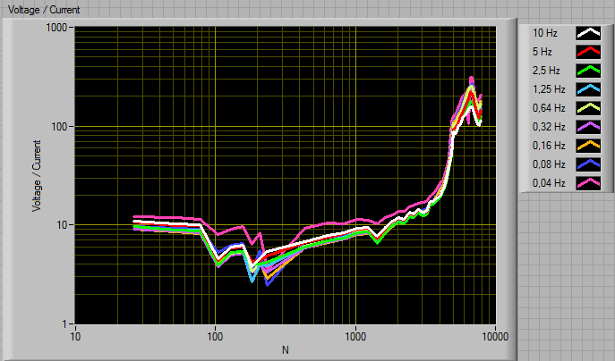
Figure XX. Electrical impedance of a random sample of the material A at different frequencies.

The electrical impedance of the iEAP materials does not depend on the working frequency, but increases significantly with the degradation of the sample (see Figure 6).

Electromechanical impedance
Electromechanical impedance is a measure of how much a structure resists motion when subjected to a given input voltage or current. In quantitative terms, it is the complex ratio of the voltage or electric current to displacement or tip angle of blocking force in the case of an alternating current (AC) input. The most distinguishable parameter is the complex ratio of electric current to the blocking force or the tip angle.

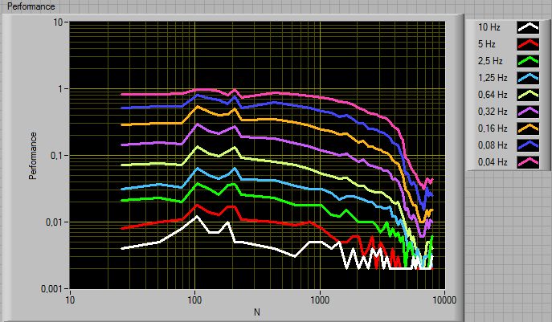
Figure XX. Performance/Voltage of a random sample of the material A at different frequencies.

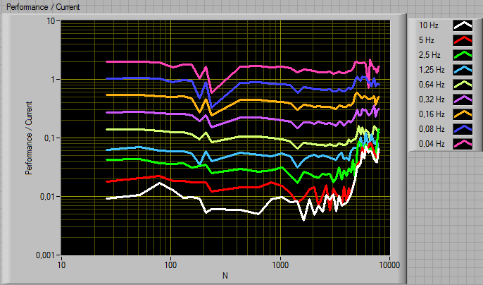
Figure XX. Performance/Current of a random sample of the material A at different frequencies.
The electromechanical impedance of the iEAP materials depends on the working frequency, and change significantly with the degradation of the sample (see Figures 7-8).

Failure criteria

Mechanical
Absolute - decrease of the performance below an absolute performance limit.
Relative - decrease of the performance below some certain ratio of initial performance

Electrical
Decrease or increase of the consumed electric current out of specified lower and upper limits. Increase of current is usually caused by a short-circuit of the device through the membrane or bet, while increase of current is usually caused by

Electromechanical
Decrease or increase of the electromechanical impedance out of specified lower and upper limits

There are two types of degradation of the iEAP materials:
- degradation during operation – the fatique of the membrane and electrodes as well as leakage of the electrolyte out of the membrane caused by its mechanical deformation;
- spontaneous self-degradation – long-term alteration of the parameters of the material caused by the ambient parameters. We noticed the spontaneous self-degradation even when the materials were held in the conditions suggested by the manufacturer, e.g. immersed in the electrolyte.

Rate of the spontaneous long-term self-degradation (RSLTD)
The performance of the iEAP materials varies even when unengaged od held in ideal conditions. For most of the tested materials the performance decreased substantially, while some of the samples of one material, showed increasing performance. Determining RSLTD involves their infrequent testing. The samples under test are held in ideal conditions, while the short performance tests are carried out rarely, e.g. in every 60 days.

End-Of-Life criteria
The performace of the iEAP actuators diminishes during working The End-Of-Life criterion (EOL) is defined as a level of performance when the actuator is considered being degraded.
In the degradation tests we used the relative End-Of-Life critreria: falling the performance below below some certain ratio of initial performance, particularly 50%, 20% and 5%

Long-term degradation of the iEAP actuators.
The test is carried out about 60 days after the first test, then two times in a weekly delay. Then, again in about 60 days the performance is measured at maximum load until the performance is decreased below EOL. Until this load test the sample is performed about 50 working cycles only, but – in general their performance has decreased noticeable. Last, in few weeks before removing the sample from the equipment, the performance is tested again. The exposure to a hazard environmental parameter (radiation, temperature, etc.), if any, is performed between the days 100-120.
The time-dependent behavior shows that during long-time idle standing the performance of the actuators of this type drifts. The long-term degradation tests show that already a single engagement of the actuator decreases its performance noticeable (days 60-85). When the performance is degraded below a certein level, its time-drift is no more observed.
The graph of the performance versus number of performed working cycles shows that at maximum load the performance decreases nearly exponentially. In spite of many efforts we could not find a functional fit of degradation matching all samples with sufficient accuracy.

The next figure depicts the electric current and performance vs. performed cycles of actuation as well as vs. the time passed from the first actuation. We can see that the trends of electric current and performance are pretty similar.

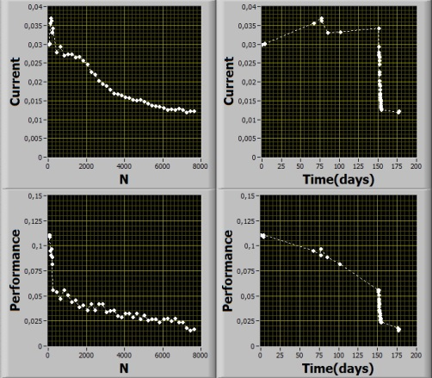

Failures
In addition to the two types of degradation, we have observed sudden destruction of the iEAP materials of 3 types
The failures are caused by the following phenomena:
- mechanical delamination or fracture of the electrodes due to too large strain;
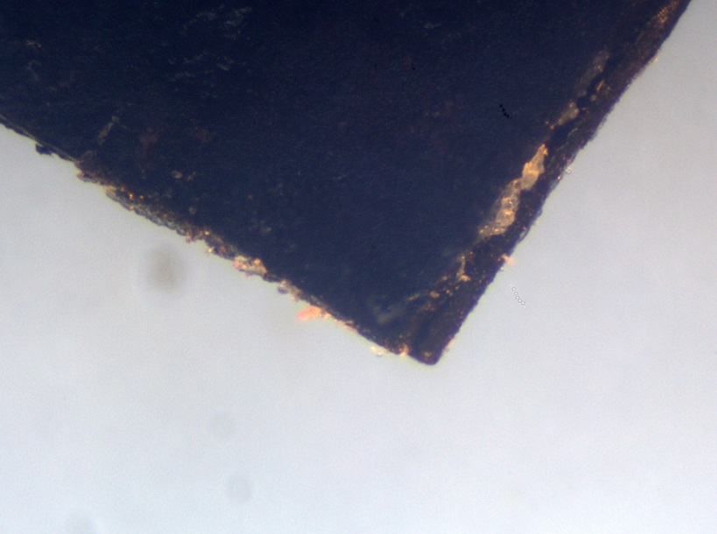
Figure XX. Optical microscope image of the delaminated electrodes.

- melting of the electrodes or the membrane due to heating by the passing electric current.

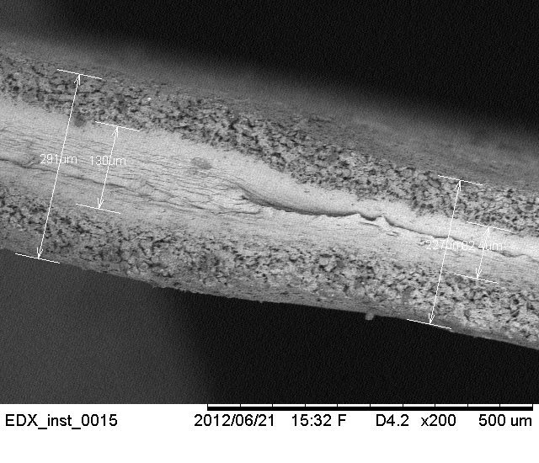
Figure XX. SEM image of a sample with melt membrane.

- Leakage of the electrolyte out of the laminate. Leaking of the electrolyte close to the electric contacts results usually with short-circuit and failure of the device, despite the laminate itself may be still functional.
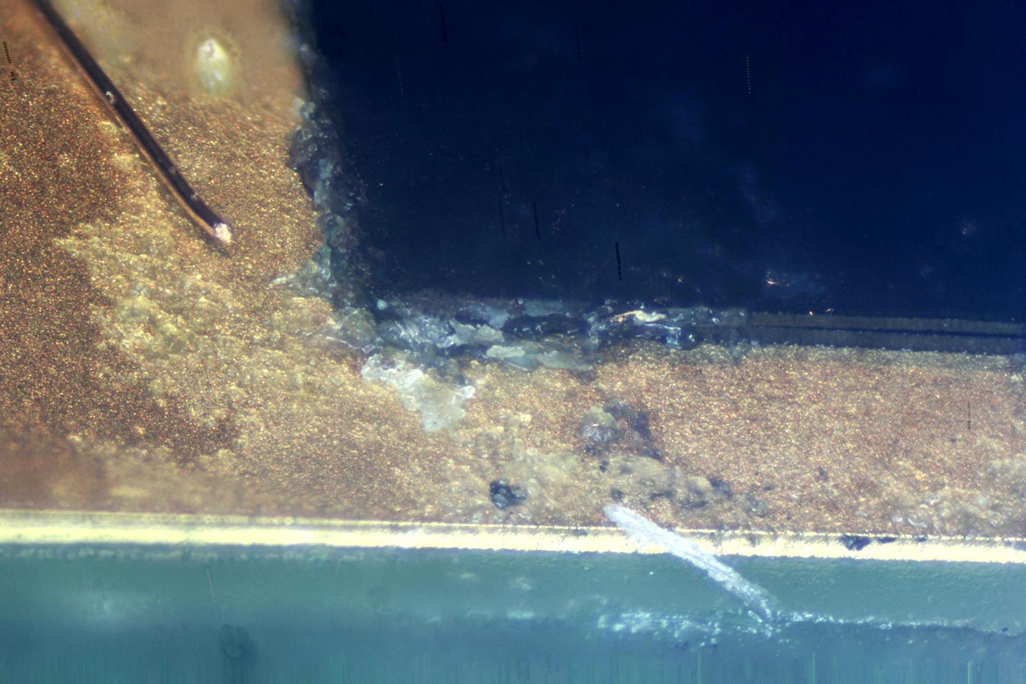
Figure XX. Optical microscope image of the melt out of the electrodes. The yellowish stick in the left side is a 50 µm copper wire for scaling purposes

Based in these failures, we describe three competing ways of reaching the end-of-life criterion in the long-term behavior of the iEAP materials:
- The progressive weakening of the performance, finally reaching the EOLend-of-life criterion. The electric current decreases with the erformance (Figure XX).

- Conductivity break-off of the sample. The sharp decrease of the electric current is accompanied by the sharp decrease of the performance below the end-of-life criterion. This is caused mainly due to the delamination of the electrodes.

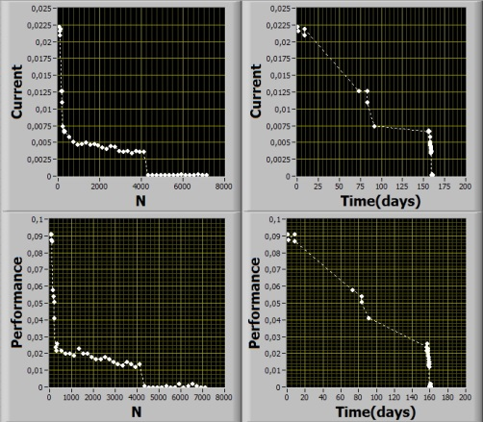

- Short-circuit of the sample. The sharp increase of the electric current is accompanied by the sharp decrease of the amplitude of bending below the end-of-life criterion (Figure 14 - C). The close inspection showed that the short-circuit happens exclusively due to the permeation of the membrane and the electrolyte between the electric contacts.

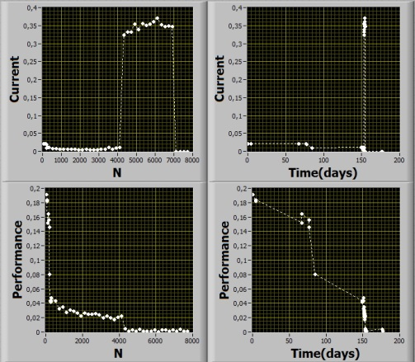

The likelyhood of happening of the two latter risks decreases significantly with reducing of the operating voltage and load.

References
http://parts.jpl.nasa.gov/asic/Appendix.3.html#cosmic.rays

