DOI: 10.1002/ ((please add manuscript number))
Article type: Full Paper

An Autonomous Sub-gram Robot Driven by an Actuating Open-air Supercapacitor

Indrek Must*, Friedrich Kaasik, Inga Põldsalu, Lauri Mihkels, Urmas Johanson, Andres Punning, and Alvo Aabloo

I. Must, F. Kaasik, I. Põldsalu, L. Mihkels, Dr. U. Johanson, Dr. A. Punning, Prof. A. Aabloo A.

Intelligent Materials and Systems Lab (http://www.ims.ut.ee), University of Tartu, Nooruse 1, Tartu, 50411, Estonia
E-mail: indrekm@ut.ee

Keywords: EAP actuators, flexible supercapacitors, in air, ionic liquids, carbon actuators

A centimeter-scale robot propelled by a supercapacitor-like ionic electroactive polymer (IEAP) laminate actuator is demonstrated. The constructed IEAP laminate with activated carbon-based electrodes stands out for its exclusive combination of high electrically-induced strain and high bending modulus, which suffices for use in microrobotics. In-air-use of the actuator is enabled by the use of ionic liquid as an electrolyte .The robot is able to carry its own power supply and even an extra payload. The microprocessor-controlled robot has an on-board lithium battery and uses a pulse width-modulated signal to drive the actuator. The 827-mg robot is able to advance on a smooth surface. The cyclic locomotion of the robot is inspired by an inchworm. The constructed biomimetic robot is distinctive for the use of a non-planar actuator that is shape-programmed during its manufacturing process. The laminate is applied concurrently as an actoator and as a construction element. The actuator has also an outstanding capacitance per surface area and a high cyclic efficiency that can be considered acceptable to be used also as an energy-storage element.

Introduction
Smart material actuators have been considered as promising materials for bio-inspired robotic applications since the beginning of their development.^{[1]} The conventional, rigid electrical motors primarily used in the robotic applications today primarily engage electron transport and magnetic fields to produce rotary motion, which is foreign to the natural organisms. Contrariwise, the actuation character of the soft ionic electromechanically active polymers (IEAP) – changes in the size or shape of the structure itself – is intrinsic to the living nature. An IEAP actuator can easily be miniaturized and, what is more, the full potential of the IEAP actuators reveals itself at the lower end of the size scale. Micro-actuators based on polypyrrole having lateral dimensions below 50 µm have been constructed with an aim towards development of lab-on-chip applications.^{[2]} There is an increasing interest in soft robots for robotic surgery,^{[3]} rescue work in the collapsed environment,^{[4]} surveillance, and manipulation of fragile objects^{[5]}.
The development of autonomous robots based on smart materials in micro-scale is a highly demanding task. Autonomous robots propelled by ionic electromechanically active polymer actuators capable of carrying their power supply have been constructed for underwater operation.^{[6]} Swimming robots require only infrequent strokes from an actuator for locomotion, as they can cover a large part of distance merely by their inertia. Autonomous in-air operation of micro-robots based on IEAP actuators has to date been challenged. The state-of-the-art in-air prototypes are, as a rule, powered through trailing wires.^{[7]}
The IEAP actuators today are characterized either by high elastic modulus, high electrically induced strain, or high strain rate. An actuator that is suitable for use in microrobotics must combine at least two of these desired properties. We developed an IEAP actuator that combines high strain and high elastic modulus in a single material, therefore opening the door towards real-world robotic applications. The actuation performance is achieved by the appropriately tuned manufacturing process and the use of carbide-derived carbon as an active electrode material. A stable in-air operation is enabled by the use of ionic liquid electrolyte.
The distinguished performance of this actuator is demonstrated on a miniature autonomous centimeter-scale robot. The locomotion of the newly-constructed robot is inspired by an inchworm, which moves by undulation of the central part of its body. The majority of the structure of the robot consists of a single IEAP actuator, which, in similar to an inchworm, morphs the shape of the whole robot. The locomotion of the robot is compared with its biological example in Figure 1AB. For optimal, biologically inspired design of the robot, the IEAP having a non-planar initial shape was constructed. The robot is microprocessor-controlled and can move autonomously on a smooth surface. The total weight of the robot is only 827 mg, including its lithium-polymer (LiPo) battery as a power supply. To our knowledge, this is the lightest autonomous EAP-based robot constructed.
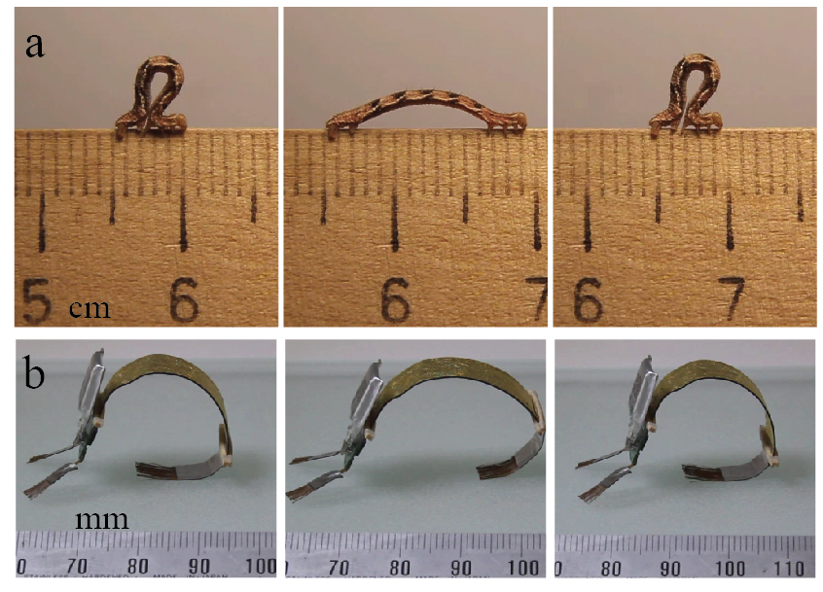
Figure 1. Locomotion of an inchworm (A) gives inspiration for the design of biomimetic robot (B).
We emphasize that the constructed IEAP actuator is virtually indistinguishable from a flexible supercapacitor. In the past few years, the development of flexible energy-storage devices, including supercapacitors, has attracted an increasing interest.^{[8-12]} The supercapacitors are, by default, expected to operate exclusively in a water-free environment due to the low electrochemical window of the water-based electrolytes. As a result, the maximum energy-density of the water-containing supercapacitors is decreased. A real-world flexible supercapacitor is, instead, often expected to operate in air; therefore, the water content can often not be ignored. We demonstrate that the IEAP with an outstanding performance as an actuator in ambient air operates efficiently also as an energy-storage element. The possibilities for designing new multifunctional devices combining actuation and energy-storage properties in a single element are consequently unveiled.

Background
Inchworm-like locomotion has previously found use in the construction of micro-robots. Hygromorphic bilayers seem to be the most-used type of actuator for this application. Centimeter-scale robots ‘walking’ on a ratcheted track have been constructed using humidity-sensitive thermally cross-linked PAH/PAA films^{[13, 14]} and graphene/graphene oxide fibers.^{[15]} This type of actuation does not involve any electric signals. Locomotion on a ratcheted surface has also been demonstrated on a gel undergoing spontaneous periodic swelling and de-swelling oscillations, gaining a speed of 130 µm min⁻¹.^{[16]} Robots based on hygromorphic or self-oscillating actuators suffer in limited control over their operation, especially if independent control of more than one actuator is desired in the construction of a robot.
Pneumatically actuated micro-robots have recently attracted increasing attention due to their high flexibility, large deformations, and a relatively high actuation speed.^{[5, 17-19]} However, these robots are connected to external pumping and commuting units via trailing tube bundles. The external pumping units can be orders of magnitudes larger and heavier than the robot itself. Obviously, such operating conditions do not resemble to the proposed fields of application. For example, autonomous operation is obviously presumed from a surveillance robot.
. The dielectric elastomer or piezoelectric actuators have typical working voltages between 500 V to 10 kV^{[20]}, limited by the dielectric breakdown voltage of the elastomer. The use of dielectric elastomers or polymer piezoelectrics in autonomous milligram-range robots is challenged due to difficulty in making miniaturized high-voltage power supplies. On the contrary, the optimal operating voltage of the IEAP actuators is in the same range with contemporary microelectronics – a few volts.
In-air operation of the shape-morphing robots that are inspired, for example, by worms^{[21]} or amoeba,^{[4]} or having engineered structures without a certain biological counterpart,^{[7]} has been demonstrated on the ionic polymer-metal composites (IPMC). As the IPMC robots rely on the presence of water as a solvent, their time of operation in air is very limited. Instead, the IPMCs show promising results in making controlled surfaces for underwater operation.^{[22, 23]}
Various types of nanocarbons – carbon nanotubes and –fibres, graphene, and carbide-derived carbons – are promising materials for construction of soft actuators.^{[24]} High anisotropic strains exceeding 50% have been recently demonstrated on activated exfoliated graphite oxide-based linear actuators by Ghaffari et al.^{[25]} However, at strain as high 56%, the elastic modulus drops dramatically - only 13% (9 MPa) is preserved at the highest strain level. Free-bending strain difference of 2.2% at 0.5 Hz has been demonstrated on a carbide-derived carbon-based bending actuator with a gold foil current-collector.^{[26]} The elastic modulus of this type of material is generally low – in the range of 30…50 MPa.^{[27]} Conjugated polymer (PEDOT; polypyrrole) actuators exhibit strain differences exceeding 3.5% at 1 V; however, the thickness of the active conducting polymer layer is usually not more than a few tens of µm,^{[28]} thus limiting the maximum achievable stress levels.

Design of the biomimetic robot

IEAP actuator
The conventional IEAP actuators are typically made in a planar sheet form. Instead, the constructed IEAP robot utilizes an actuator with a curved initial shape. The initial shape is programmed using heat-treatment during the manufacturing process. The initial shape of the actuator retained well during the performed experiments.
An IEAP with non-planar shape is advantageous due to the following consideration: It is known that by applying electric charge between the IEAP actuator, the strain difference is formed between the sizes of opposite electrodes. Consequently, a piece of IEAP with comparable dimensions in length and width turns into a bowl shape. The initially curved shape helps to confine the preferred direction of bending action to the lengthwise rather than to the transverse (width) direction.
In addition to the use of curved initial shape, the key for the fabrication of an actuator with a high strain and stress lies in the precise selection of the ratio between components in the electrode and the thickness ratio between the membrane and the electrode. The thickness of the cast membrane is approximately 120 µm. A total of approximately 20 layers of electrode were painted on the actuator to achieve a total thickness of 450 µm. The scanning electron microscope image of the cross-section of the IEAP is given in Figure 2.
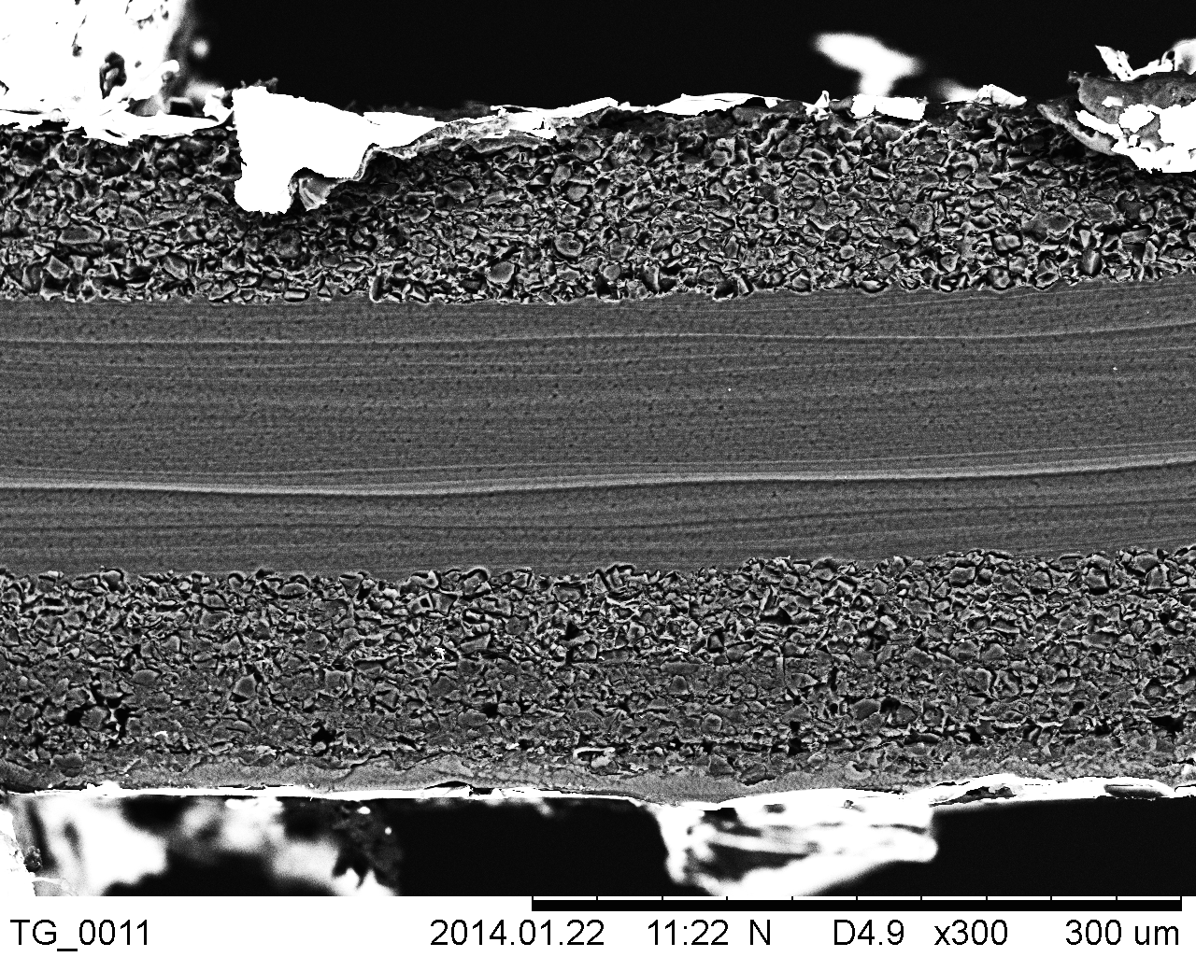
Figure 2. Scanning electron micrograph of the cross-section of the IEAP.

Construction of the Robot
The constituents of the robot are depicted in Figure 3A. The constructed robot has an on-board microcontroller, which is responsible for generation of the control waveform to achieve cyclic motion. Current is amplified using an H-bridge integrated circuit. The robot carries along its power supply. Due to the high current requirement of the IEAP actuator, a lithium-polymer (LiPo) rechargeable battery was chosen.
The weight proportions for the components are given in Figure 3B. As expected, the heaviest component in the system is the LiPo battery, which gives 42% of the total weight of the robot. The weight of the IEAP actuator itself is just over one quarter of the total mass. Surprisingly, the weight of the actuator was equal to the weights of driving electronics and other construction elements (except the LiPo) together.
The details regarding the construction of the robot are given in the Supplementary Materials.
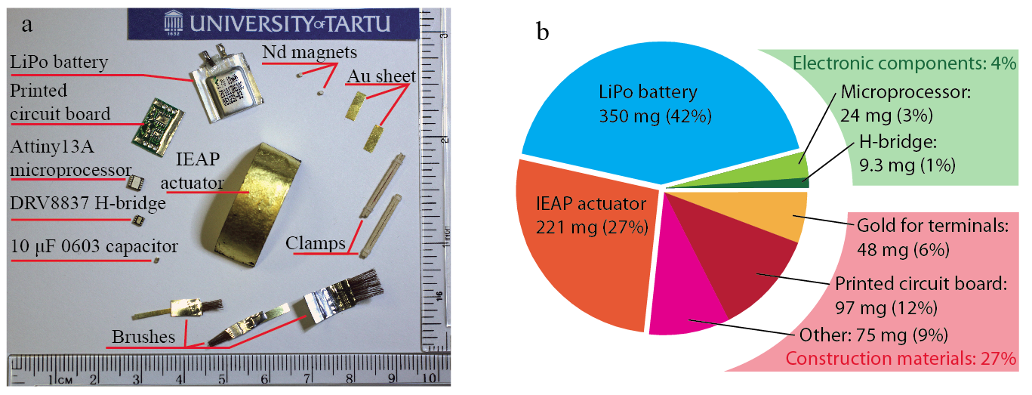
Figure 3. (A) Construction elements of the IEAP robot. (B) Weight proportions of the components.

Results

Pulse width modulation (PWM) control for IEAPs
The IEAP was driven using a bipolar signal, which consisted of longer charging periods with alternating polarity followed by short-circuiting periods. The two outputs of the driver IC are switched between three states – it is either connected to the positive or negative LiPo terminal, or it has a high-impedance output. The timing for one cycle is depicted in Figure 4A. The pulse-width-modulated (PWM) signal consists of voltage pulses of width T_{a} after every period T_{PWM}. The duty cycle of the PWM signal is expressed as T_{a}/T_{PWM}.
During each charging period, the IEAP was driven using a PWM signal with a constant period and frequency. In the timeframe of 10 s, a constant PWM signal resulted in galvanostatic charging of the IEAP. The duty cycle of the PWM signal determines the charging current averaged in time and therefore the amount of charge injected to the IEAP in one charging cycle. Figure 4B shows that the IEAP charging current dropped only 20% after a 10-s charging cycle.
Figure 4D gives a typical course of voltage on the IEAP terminals during one working cycle. After 10 s, the open-circuit voltage between the IEAP electrodes rose only to 1 V. An open-circuit voltage as low was found to induce already a peak-to-peak bending deflection of 45 m⁻¹ and 2.0 gf of blocking force between the opposite ends of a 40x10-mm actuator. (Two millimeters of the IEAP was rigidly clamped between the terminals; therefore, the free length was 38 mm.) The corresponding transient courses of deflection and force are given in Figure 4C. The blocking force was measured at the tip of the actuator in perpendicular to its surface, as explained in the inset of Figure 4C. Such an amount of deflection and force already sufficed to successfully drive the IEAP robot; therefore, the voltage was not increased further. An additional increase in the terminal voltage would have caused higher deflection and force at the cost of increased time per one working cycle. The used input signal resulted in a stable operation of the actuator – no noticeable decrease in its performance was observed during hundreds of performed working cycles.
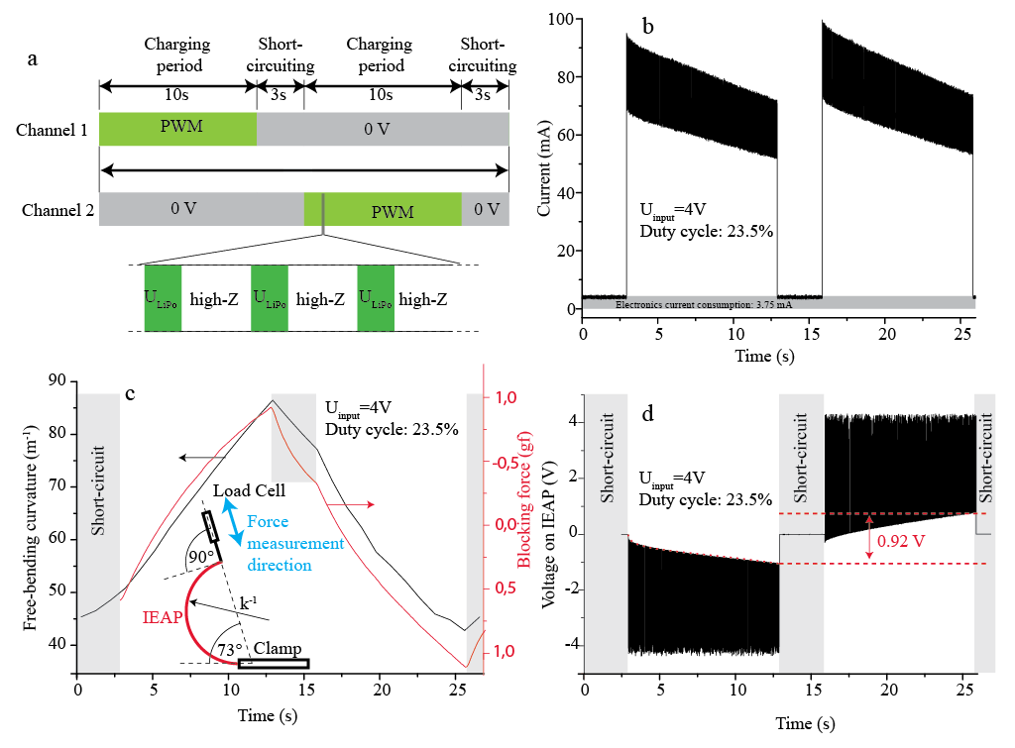
Figure 4. Control waveform for one working cycle of the robot. Transient courses of b) electric current of the whole robot; c) of free-bending curvature and blocking force, and d) voltage on the IEAP terminal during one working cycle.

Current collectors
Both sides of the IEAP actuator were covered with current collector composed of three layers of gold foil. The gold foils were glued together and on the electrode using Nafion solution. It is important that the nanoscale-thickness gold foil is a continuous layer of metal, therefore having high electric conductivity. Figure 5 demonstrates that three layers of 130-nm gold foils provide surface resistance that is only two times higher than the calculated theoretical resistance value for the gold foils. Due to low thickness, the gold current collector was compliant and its resistance did not change considerably when bent, as shown in Figure 5A.
Compliant electrodes are sought also for use in dielectric elastomer actuators.^{[29]} Because the dielectric elastomers are driven with high voltage and low current, the surface resistances in the range of 1…1kΩ already suffice. In IEAP actuators, instead, the surface resistance is more critical due to high currents involved. In supercapacitors, thick solid aluminum current collector is frequently used.^{[30]} This provides excellent conductivity, but is not compliant. A compact gold foil current collector has been found to provide the lowest surface resistance without compromising the flexibility of the laminate. The gold layer is compliant and flexible due to its pre-buckled shape, which is achieved during the manufacturing process. Please see Supplementary Information for details on the pre-buckling process. Nafion polymer, which is used in bonding of the gold layers, also acts as an elastic layer precluding cracking of the gold layers.
It is remarkable that the voltage difference is established immediately over the whole IEAP surface area. In Figure 5B it can be observed that the voltage on the IEAP electrodes alternates between the level of open-circuit voltage and the LiPo terminal voltage at the frequency of 32 kHz. At all times, the voltage on the opposite ends of the IEAP with a voltage applied only from one end remains uniform, as given in Figure 5B. To the contrary, certain types of IEAPs, such as IPMCs with chemically plated platinum electrodes, have surface resistances as high as the signal propagation along the electrode is described as a finite transmission line,^{[31]} in turn complicating the control of this type of actuator.
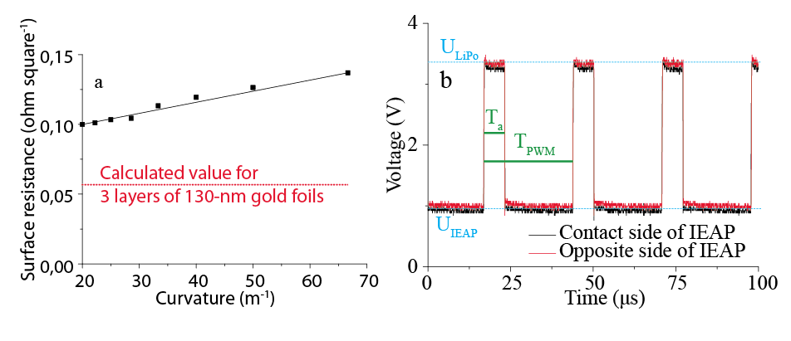
Figure 5. a) Surface resistance of the IEAP with gold foil as current collectors. b) Voltages at the opposite ends of the IEAP actuator during PWM input signal.

Locomotion characteristics of the constructed robot
The robot was driven with a control signal depicted in Figure 4A, with the PWM duty cycle fixed at 23.5%. The robot touched the ground via miniature brushes aligned in one direction. By doing so, both ends of the inchworm-like shape-morphing robot could slide only in one direction, while the movement is blocked in the opposite direction. The robot is able to move on the surfaces that have the necessary amount of roughness – cardboard and satin glass provided the best results. Figure 4A-C depicts morphing of the shape of the IEAP robot moving on a satin glass during one working cycle. The robot moved 16 mm in one 26-s working cycle. The robot’s ability of performing useful work is demonstrated in Figure 4D-F. The robot carries a steel washer as a payload, which weighs exactly as much as the robot itself – 830 mg, on a cardboard surface. The workload does not reduce considerably the speed of the robot – it still advanced 14 mm during one working cycle in the driving conditions equal to the previous experiment. In Figure 4G-I, the robot moves up the hill with an angle of climb of 11º. The robot advanced 14 mm in one working cycle of equal parameters with the previous experiments. In Figure 4J-K, the robot, which is hanging on steel pins from one of its ends, lifts itself up. It proves that the rigidity of the IEAP actuator is chosen properly, so that the weight of the robot does not constrain its actuation.
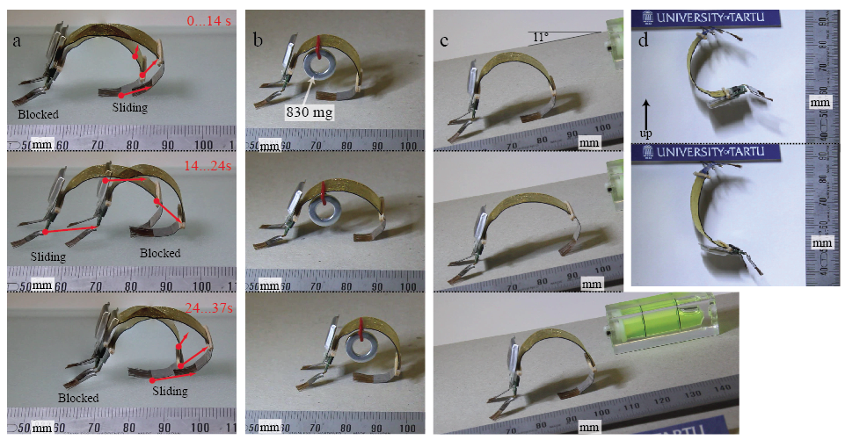
Figure 6. Locomotion of the IEAP robot. a) The robot is advancing on a satin glass plate. b) The IEAP robot carrying a payload with the weight equal to the robot itself. c) The robot climbing up a cardboard inclined at 11°. d) The robot lifting itself up.
The video files for all of the described experiments are available in the Supplementary Materials.

Electromechanical performance of the material
Electromechanical performance of the constructed IEAP actuator was investigated using a sinusoidal input signal. In the free-bending mode, the curvature of the IEAP changed uniformly in the whole length of the laminate; therefore, it is possible to determine the IEAP curvature by fitting an arc over the image of the IEAP cross-section, as depicted in Figure 7A. The blocking force increased proportionally with the amplitude of sinusoidal input voltage, as given in Figure 7A. As shown in Figure 7B, the curvature increased exponentially with the increased input voltage amplitude.
The measurements show that the performance of the IEAP actuators is limited by the amount of charging current averaged in time, not considerably affected by the type of driving signal. Limiting of the time-averaged charging current is important for increasing the IEAP lifetime, because the thin gold current collector layer could heat up as a result of high charging currents. The cross-section of each of the 130-nm current collectors on a 10 µm wide IEAP is only 1.3x10⁻³ mm². Consequently, the speed and deflection rate of an IEAP actuator is limited by the amount of current passing through the material, eventually heating up the actuator. Figure 7C shows a more pronounced decrease between the bending curvature and blocking force at charging currents above 90 mA for a 4-cm² IEAP. Thus, a time-averaged charging current of up to 25 mA cm⁻² is optimal for driving this type of actuator.
Figure 7D gives the values for the calculated bending modulus in relation to the amount of electrical charge consumed by the IEAP in one working cycle. The bending modulus is calculated from the deflection and blocking force amplitude as given by Equation (1), where B is bending modulus, σ is stress, ε is strain, φ_{K} is the phase of curvature, and φ_{Q} is the phase of charge. φ_{Q} is calculated as $φ_{F}=φ_{I}+90°$, where φ_{I} is the phase of electric current.
 | $$B=\frac{σ}{ϵ}\cos\left(φ_{K}-φ_{F}\right),$$ | (1)
The calculation is explained in more detail in Supplementary Information. It can be observed that the bending modulus B decreases linearly with increasing amount of consumed charge. Extrapolation gives the value of 334 MPa for bending modulus without applying electrical input. The difference in the bending modulus at an increased working voltage and current is, however, notable and should be considered in the design of applications based on the IEAP actuators.
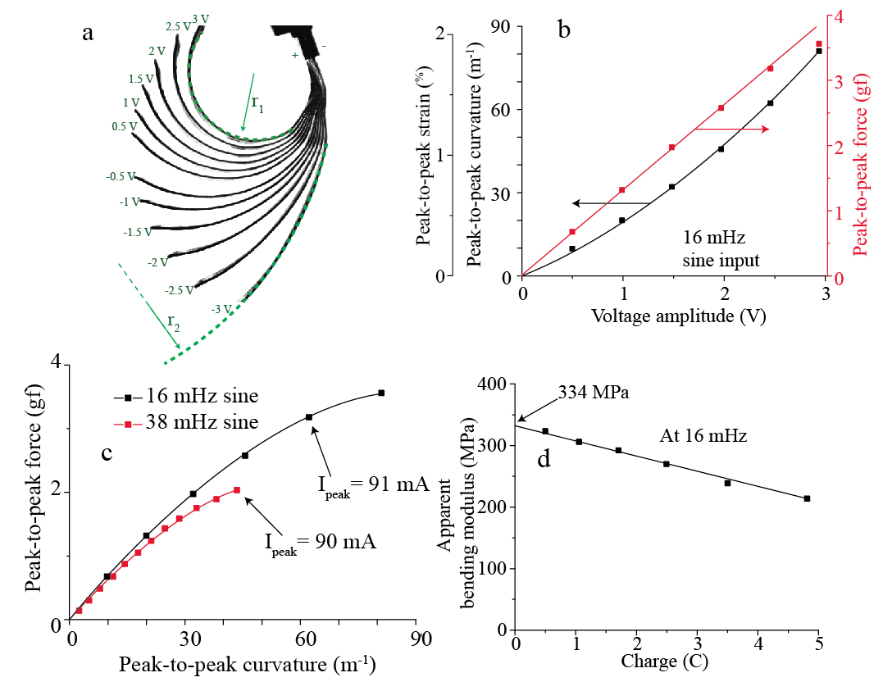
Figure 7. The performance of the IEAP actuator in response to sinusoidal input signal. a) The composite image of the cross-sections of IEAP actuator at various input signal amplitudes. b) The strain difference and blocking force at different input voltage amplitudes. c) The decrease in the blocking force at high charging currents. d) The apparent bending modulus at different levels of consumed charge per one cycle.

Energy-storage efficiency
The newly-constructed IEAP laminate is optimized for actuation; however, it still has a remarkable energy-storage property in air. Cyclic efficiencies for the supercapacitors are typically not given in the literature, because they are, by default, expected to operate completely without the presence of water. However, the cronocoulonometry experiment results presented in Figure 8A demonstrate a cyclic energy-storage efficiency of 93.5% in ambient air. (The corresponding ambient relative humidity was 10±4% during the experiments.) Therefore, the constructed IEAP material can potentially also used as an energy-storage medium. What is more, its areal capacitance, calculated from the cronocoulonometry data, is remarkably high – more than 151 mF cm⁻². This is comparable to the highest capacitance-per-area values reported for micro-supercapacitors today.^{[33]} The gravimetric capacitance of the 55-mg-cm⁻² IEAP is 2.7 F g⁻¹ and the volumetric capacitance of the 450-µm laminate is 3.4 F cm⁻³. Nevertheless, as it is also emphasized by Beidaghi et al. in their recent review paper,^{[33]} the primary consideration for the development of micro-scale supercapacitors is their footprint per surface area, not their gravimetric capacitance.
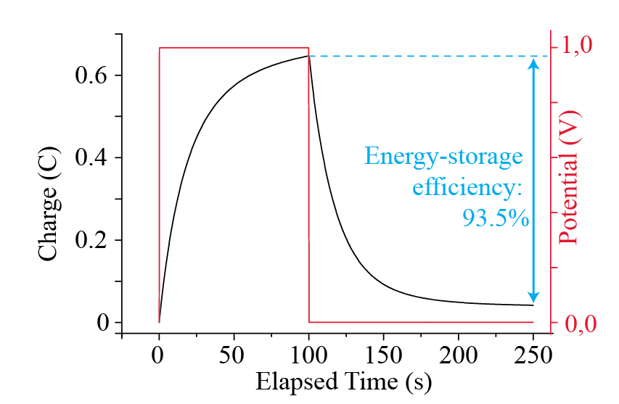
Figure 8. Energy-storage efficiency of the IEAP actuator.

Conclusions
This work presents the first IEAP robot that can autonomously operate in air. The constructed robot is very light (total weight 830 mg) and measures less than 4 cm. The results demonstrate the advantage of the IEAP technology especially in small-scale devices – the size of the robot was determined especially by the size of available power supplies, whereas the IEAP actuator itself could easily be used to make considerably smaller robots.
The IEAP actuator technology conforms well to the state-of-the-art microelectronics. The actuator and the driving electronics are both powered directly from a one-cell lithium-polymer battery. A cheap and widely-available PWM-based driver integrated circuit is successfully used in the control board for driving the actuator. In the constructed robot, the weight of electronic components is inconsiderable compared to its other construction elements, which opens possibilities for further miniaturization.
The robot is driven by a single IEAP actuator. The construction of the actuator is optimized for having simultaneously high bending modulus and high strain. At ±3V input voltage, a 3.8-cm piece of laminate generated blocking force as much as 36 mN (3.6 gf). In the free-bending mode, the laminate has an electrically-induced strain difference of 1.8% at 3 V. These levels of strain and force suffice for use in microrobotics. In fact, voltage as low as 1 V is already sufficient to successfully drive the robot.
The biomimetic design suggests the use of IEAP actuator in a non-planar configuration. In the manufacturing process the actuator was programmed having a U-shape. The programmed shape remained unchanged in the course of actuation.
The constructed IEAP actuator stands out by its remarkable efficiency. Although the IEAP actuators are very similar in construction to the supercapacitors, their energy-storage efficiency is usually low. The efficiency of the actuator was improved by the use of multiple layers of thin gold sheet as current collectors. The compliant gold current collector provided the necessary level of electronic conduction without compromising the flexibility of the laminate. An energy-storage efficiency of 93.5% was measured.
The constructed inchworm-like robot has a top speed of 36 mm min⁻¹, which makes it demonstrably slower than its biological example. However, it could rival a garden snail, which has a top speed of only 1 m h⁻¹,^{[34]} in a sprint contest.

Experimental

Fabrication of the actuator
The membrane of the IEAP laminate was fabricated by casting the IL-incorporated PVdF membrane into a mold. Subsequently, the electrodes were formed by spray-painting a mixture of carbide-derived carbon, PVdF(HFP) polymer, and EMITFS ionic liquid, and appropriate solvent directly on both sides of the cast membrane. Spray-application of the electrodes, also known as ‘direct assembly process’ (DAP), has previously been used by Akle et al.^{[35]} and Palmre et al.^{[36]} Subsequently, three layers of 130-nm gold sheet were glued on both sides of the laminate to form current collectors. The curved shape was obtained by fitting the IEAP laminate on a cylindrical tube and simultaneously heating the whole construction up to 100ºC. After cooling the IEAP was removed from the tube.

Electrical and mechanical measurements
The current consumption of the robot was measured by applying a 4-V input from an external laboratory power supply while registering the consumed current. The terminal voltages were registered using National Instruments PCI-6036E and 6XXX DAQ devices. Tektronix TDS 2024B oscilloscope was used in the measurements in Figure 5B.
The chronocoulonometry experiment was performed on a PARSTAT 2273 potentiostat.
Blocking force was measured using an ADInstruments MLT0202 load cell.
The actuation was recorded by a DMK 22BUC03 USB camera equipped with a long-focus lens C5028-M. The curvature amplitude was determined by fitting the recorded image of the IEAP with a circle of variable radius using National Instruments LabView software package. The amplitudes and phases corresponding to a sinusoidal input were determined by fitting the measured data using a differential evolution algorithm implemented in LabView.
Scanning electron microscope Hitachi TM3000
Resistance: Agilent 34420A micro-ohm meter.

Acknowledgements

References
References
[1] K. J. Kim, S. Tadokoro, Electroactive Polymers for Robotic Applications: Artificial Muscles and Sensors, Springer2007.
[2] E. W. Jager, E. Smela, O. Inganäs, , Science. 2000, 290(5496), 1540-1545.
[3] K. Aw, L. Fu, A. McDaid, , International Journal of Smart and Nano Materials. 2013(ahead-of-print), 1-11.
[4] J. Hou, M. Luo, T. Mei, "The design and control of amoeba-like robot", presented at Computer Application and System Modeling (ICCASM), 2010 International Conference on2010.
[5] S. W. Kwok, S. A. Morin, B. Mosadegh, J. So, R. F. Shepherd, R. V. Martinez, B. Smith, F. C. Simeone, A. A. Stokes, G. M. Whitesides, , Advanced Functional Materials. 2013.
[6] S. McGovern, G. Alici, V. Truong, G. Spinks, , Smart Mater. Struct. 2009, 18(9), 095009.
[7] A. Firouzeh, M. Ozmaeian, A. Alasty, , Smart Mater. Struct. 2012, 21(6), 065011.
[8] Y. Li, R. Torah, S. Beeby, J. Tudor, "An all-inkjet printed flexible capacitor for wearable applications", presented at Design, Test, Integration and Packaging of MEMS/MOEMS (DTIP), 2012 Symposium on2012.
[9] D. Wei, T. W. Ng, , Electrochemistry Communications. 2009, 11(10), 1996-1999.
[10] J. Bae, M. K. Song, Y. J. Park, J. M. Kim, M. Liu, Z. L. Wang, , Angewandte Chemie International Edition. 2011, 50(7), 1683-1687.
[11] H. Gwon, H. S. Kim, K. U. Lee, D. H. Seo, Y. C. Park, Y. S. Lee, B. T. Ahn, K. Kang, , Energy & Environmental Science. 2011, 4(4), 1277-1283.
[12] L. Nyholm, G. Nyström, A. Mihranyan, M. Strømme, , Adv Mater. 2011, 23(33), 3751-3769.
[13] Y. Ma, Y. Zhang, B. Wu, W. Sun, Z. Li, J. Sun, , Angewandte Chemie. 2011, 123(28), 6378-6381.
[14] S. Lee, J. H. Prosser, P. K. Purohit, D. Lee, , ACS Macro Letters. 2013, 2, 960-965.
[15] H. Cheng, J. Liu, Y. Zhao, C. Hu, Z. Zhang, N. Chen, L. Jiang, L. Qu, , Angewandte Chemie International Edition. 2013, 52(40), 10482-10486.
[16] S. Maeda, Y. Hara, T. Sakai, R. Yoshida, S. Hashimoto, , Adv Mater. 2007, 19(21), 3480-3484.
[17] F. Ilievski, A. D. Mazzeo, R. F. Shepherd, X. Chen, G. M. Whitesides, , Angewandte Chemie. 2011, 123(8), 1930-1935.
[18] S. A. Morin, R. F. Shepherd, S. W. Kwok, A. A. Stokes, A. Nemiroski, G. M. Whitesides, , Science. 2012, 337(6096), 828-832.
[19] B. Mosadegh, P. Polygerinos, C. Keplinger, S. Wennstedt, R. F. Shepherd, U. Gupta, J. Shim, K. Bertoldi, C. J. Walsh, G. M. Whitesides, , Advanced Functional Materials. 2013.
[20] P. Brochu, Q. Pei, , Macromolecular rapid communications. 2010, 31(1), 10-36.
[21] P. Arena, C. Bonomo, L. Fortuna, M. Frasca, S. Graziani, , Systems, Man, and Cybernetics, Part B: Cybernetics, IEEE Transactions on. 2006, 36(5), 1044-1052.
[22] V. Palmre, J. J. Hubbard, M. Fleming, D. Pugal, S. Kim, K. J. Kim, K. K. Leang, , Smart Mater. Struct. 2013, 22(1), 014003.
[23] A. Punning, M. Anton, M. Kruusmaa, A. Aabloo, "A biologically inspired ray-like underwater robot with electroactive polymer pectoral fins", presented at International IEEE Conference on Mechatronics and Robotics2004.
[24] U. Kosidlo, M. Omastová, M. Micusík, G. Ćirić-Marjanović, H. Randriamahazaka, T. Wallmersperger, A. Aabloo, I. Kolaric, T. Bauernhansl, , Smart Mater. Struct. 2013, 22(10), 104022.
[25] M. Ghaffari, W. Kinsman, Y. Zhou, S. Murali, Q. Burlingame, M. Lin, R. Ruoff, Q. Zhang, , Adv Mater. 2013.
[26] J. Torop, T. Sugino, K. Asaka, A. Jänes, E. Lust, A. Aabloo, , Sensors Actuators B: Chem. 2012, 161(1), 629-634.
[27] J. Torop, V. Palmre, M. Arulepp, T. Sugino, K. Asaka, A. Aabloo, , Carbon. 2011, 49(9), 3113-3119.
[28] R. Temmer, A. Maziz, C. Plesse, A. Aabloo, F. Vidal, T. Tamm, , Smart Mater. Struct. 2013, 22(10), 104006.
[29] S. Rosset, H. R. Shea, , Applied Physics A. 2013, 110(2), 281-307.
[30] P. Aza'is, , Supercapacitors: Materials, Systems and Applications. 2013.
[31] A. Punning, M. Kruusmaa, A. Aabloo, , Sensors and Actuators A: Physical. 2007, 133(1), 200-209.
[32] E. Shoji, Y. Komoda, , Polym. Adv. Technol. 2013.
[33] M. Beidaghi, Y. Gogotsi, , Energy & Environmental Science. 2013.
[34] Anonymous Study of 450 garden snails, Cornu aspersum, in a typical rough lawn habitat, University of Exeter2013.
[35] B. J. Akle, M. D. Bennett, D. J. Leo, K. B. Wiles, J. E. McGrath, , J. Mater. Sci. 2007, 42(16), 7031-7041.
[36] V. Palmre, E. Lust, A. Janes, M. Koel, A. Peikolainen, J. Torop, U. Johanson, A. Aabloo, , J.Mater.Chem. 2011.

Supplementary information

Manufacture of the IEAP
The three-layer iEAP actuator was manufactured using a ‘direct assembly’ process proposed by Akle et al. The constructed laminate has a non-planar zero curvature (stable curvature without applying voltage) of 15 mm. The thickness of the finished iEAP laminate was 450 µm.
The membrane was manufactured by solvent-casting method. First, a mixture of 1-ethyl-3-methylimidazolium trifluoromethanesulphonate (EMITFS) (Fluka, ≥99.0 %), poly(vinylidene fluoride-co-hexafluoropropene) (PVdF-HFP), 4-methyl-2-pentanone (MP), and propylene carbonate (PC) was prepared (Figure 9A).
MP and PC were purchased from Sigma-Aldrich Co. Dimethylacetamide (DMAc) and EMITFS from Fluka.
The electrode material was prepared by dispersing TiC-CDC powder (Skeleton Technologies) with 15 wt% Nafion solution (LIQUION® LQ-1115 1100EW; Ion Power, Inc). An ultrasonic probe was used to promote homogenization. The dispersion was painted layer-by-layer directly on both sides of the cast PVdF-IL membrane using an airbrush (Figure 9B). Approximately 20 electrode layers were applied on both sides of the membrane. Then the volatile solvents were evaporated using hot air.
The laminate was subsequently fixed on the outer surface of a cylindrical tube with a diameter of XX mm. Three layers of ~130 nm gold foil (Gold-Hammer) were placed on top of the outer electrode (Figure 9C). A drop of Nafion solution was used as glue. Then, the laminate was turned around on the surface. Then the tube with the laminate on its surface was heated using a hot air gun to just below its melting point (approximately 100°C) (Figure 9D). Another 3 layers of gold were subsequently attached on top of the opposite (stretched out) electrode (Figure 9D). Then the IEAP was removed from the surface of the tube. After manufacture, the IEAP retained its newly-programmed initial shape.

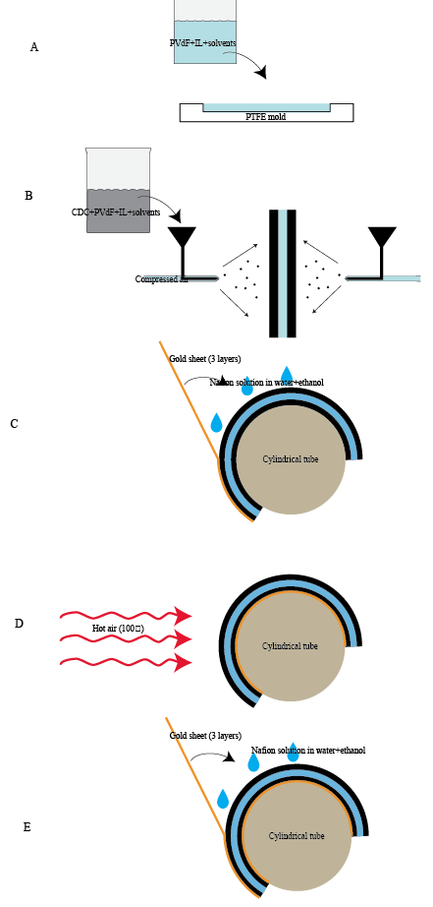
Figure 9. Manufacturing process for the IEAP

Design of the robot

Control board
An ATTINY13A microprocessor by Atmel Corporation in a 10-pin 3×3×1.0 mm MLF package was selected as the control unit. The two PWM outputs of the microcontroller were connected to a DRV8837 H-bridge by Texas Instruments in a 2×2×0.8-mm WSON-8 package for current amplification. The outputs of the H-bridge were connected directly to the gold terminals for connecting to the IEAP.

Power supply
A 10 mAh 10C LiPo battery cell was chosen as a power supply. Small neodymium magnets were attached to the battery and the control board, so that the battery could be easily attached and detached. The magnets also prevented from connecting the battery with the opposite polarity.

Brakes
Directional locomotion was achieved by the use of miniature brushes placed under the robot and directed to an appropriate direction. The robot touches the ground only via the brushes at all times. By placing the robot on a surface with an appropriate roughness, the brushes act as a brake, blocking the sliding motion in one direction.

Clamping and terminals
The corrosive nature of the ionic liquid electrolyte demands for terminal materials of high electrochemical stability. In this purpose, terminals made of solid gold sheet were fabricated. Appropriate clamping pressure was achieved by an additional clamp made of balsa wood.

Efficiency of the PWM driving signal
The highest open-circuit voltage, which is in turn related to the level of charging, increases in proportion to the PWM duty cycle, as depicted in Figure 10A. The amount of charge required in each cycle, instead, increases exponentially with the increase in PWM duty cycle. The driving electronics itself consumes current at a constant level of 3.8 mA. The relation between the amount of charge needed by the electronics and the IEAP is illustrated in Figure 10A – at 23.5% duty cycle, 10 % of the charge is consumed by the driving electronics. Nevertheless, the duty cycle of 12% provides the most force per consumed charge, as shown in Figure 10B.
In-between the consecutive charging cycles the actuator was short-circuited by applying the same voltage to both of the electrodes, as illustrated in Figure 4A. In particular, both of the electrodes were connected to the negative terminal of the LiPo battery. (In the case of using the same H-bridge to drive DC motors, this regime restrains the DC motor from turning.) It is important that by using an H-bridge for short-circuiting, no additional current was drawn from the battery, as shown in Figure 4B. For a comparison, when the IEAP is driven with a sinusoidal or rectangular input voltage, the energy stored in the battery is consumed for both charging and discharging of the IEAP. The use of a 3-s short-circuiting cycle between the working cycles provided up to 15% higher force and 10% more force per charge, as given in Figure 10B.
The performance of the IEAP driven with a sinusoidal and a PWM input signal is compared in the Supplementary Materials.
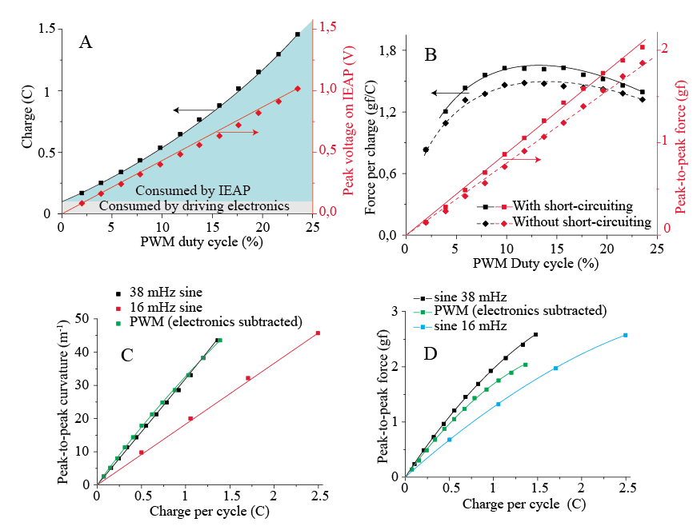
Figure 10. a) The consumed electric charge and the peak open-circuit voltage on the IEAP at different PWM duty cycles. b) Energy saving by short-circuiting.
In the field of IEAPs, PWM control has been previously applied by Shoji et al. on the IPMC actuators to achieve a better control over the force and displacement.^{[32]} Shoji, however, used a PWM control signal which is substantially different from the signal used in this work. In Shoji’s work, the control voltage alternates between the maximum voltage (2 V) and the short-circuit condition in every working cycle. By doing so, the IPMC is both charged and discharged during each PWM period. The total accumulated charge is related to the PWM duty cycle, but the power losses increase with the decrease in the duty cycle. Obviously, such a driving signal wastes energy and is therefore not suitable for use in autonomous devices. Moreover, in the Shoji’s work, the PWM is applied at frequencies as low as it causes the actuator to respond by vibrating along (2…100 Hz), which is unnecessary and does not convey the essence of the PWM signal – current control.

Performance comparison between PWM and sinusoidal driving signal
It is important to note that neither the performance nor cycling stability of the IEAP actuator suffered as a result of a pulsed control signal with the voltage on its terminals alternating between 0 and 4 V at 32 kHz. Figure 10C demonstrates that virtually the same amount of charge is consumed both in the case of sinusoidal and PWM driving signals of equivalent cycling frequency to achieve the same bending curvature amplitude. The maximum blocking force shows a small (15%) decrease compared to sinusoidal input of the same frequency, as depicted on Figure 10D. The blocking force is, however, sensitive to the cycling frequency - Figure 10D shows that the blocking force decreases 30% at twice lower cycling frequency.

Bending stiffness
Figure 7C gives the transient courses of blocking force and free-bending curvature measured in the equal driving conditions. A phase lag of 30º between curvature and force can be observed. The existence of a phase lag was not expected; therefore, it needs a closer look. Figure 7D gives phase differences for curvature and force in relation to input charge. As the electric charge is an integral of the input current, the phase of charge, φ_{Q}, was determined by shifting the phase of electric current by 90º. At 3 V input voltage, the phase of force leads charge (expressed as φ_{F}-φ_{Q}) by 42º, while the phase of blocking force (expressed as φ_{K}-φ_{Q}) leads only by 12º.
It is expected that the neutral plane (a plane with zero strain/stress in bending) is located in the middle of the IEAP. Therefore, the maximum linear strain, ε, can be given as
 | $$ε=\frac{\frac{1}{2}t}{k},$$ | (2)
where t is thickness of the IEAP laminate and k is curvature. The values for linear strain are given in Figure 7A. If the IEAP is constrained from bending during the measurement of blocking force, the laminate can be looked as a spring with its initial curvature changed by electrical input. The bending moment can be calculated as
 | $$M=\frac{l}{F},$$ | (3)
where M is bending moment, l is length of the actuator, and F is blocking force. Therefore, in case of a linear-elastic material, it is possible to calculate the stress, σ, as
 | $$σ=\frac{\frac{1}{2}tM}{I},$$ | (4)
where I is area moment of inertia for a beam of rectangular cross-section. I can be calculated for a beam of length l as
 | $$I=\frac{lt^{3}}{12}.$$ | (5)
Knowing the stress and strain, it is possible to calculate the bending modulus, B, of the laminate. However, the phase difference between curvature (i.e. strain) and blocking force (i.e. stress) – φ_{K}-φ_{F} – must be taken into account as follows:
 | $$B=\frac{σ}{ϵ}\cos\left(φ_{K}-φ_{F}\right).$$ | (6)
Therefore, from the formulae above, B can be calculated for each input signal as
 | $$B=\frac{l^{2}t^{2}}{6F}\cos\left(φ_{K}-φ_{F}\right).$$ | (7)

Performance of the actuator under sinusoidal input signal
At 3V sinusoidal input voltage, the electric current increased up to 130 mA, as shown in Figure 7B.
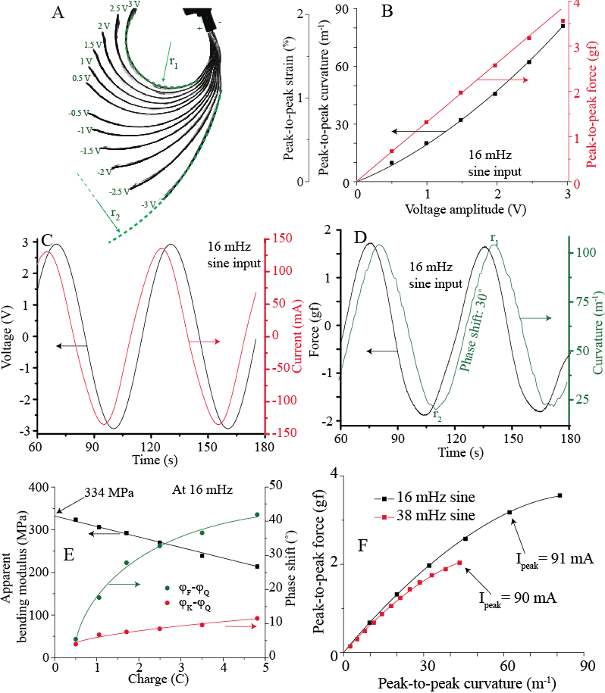

Code

Test signal
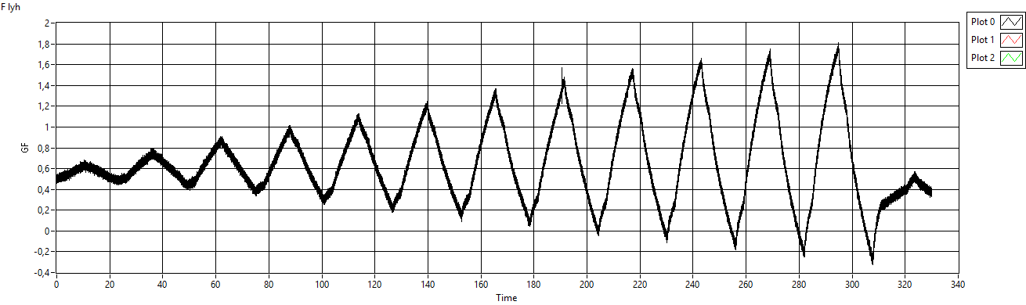
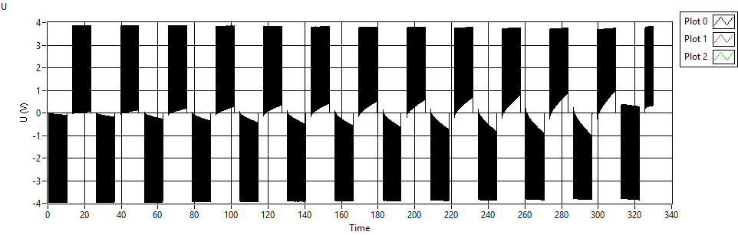

Working signal

Electrical schematic
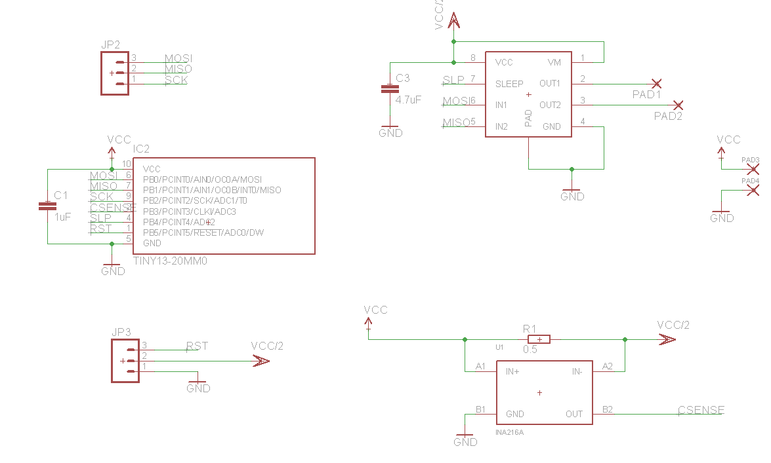

PCB
